CONNECTED, LEVEL 2 2015, Have You Checked?  Operation Duck Pond  by Andrew Gunn  Overview  This article describes how Nathan Burkepile, a scientist with Fish and Game New Zealand, engages the help of citizen scientists for his research into what makes a pond a good breeding habitat for ducks.  A Google Slides version of this article is available at www.connected.tki.org.nz. |  |  | 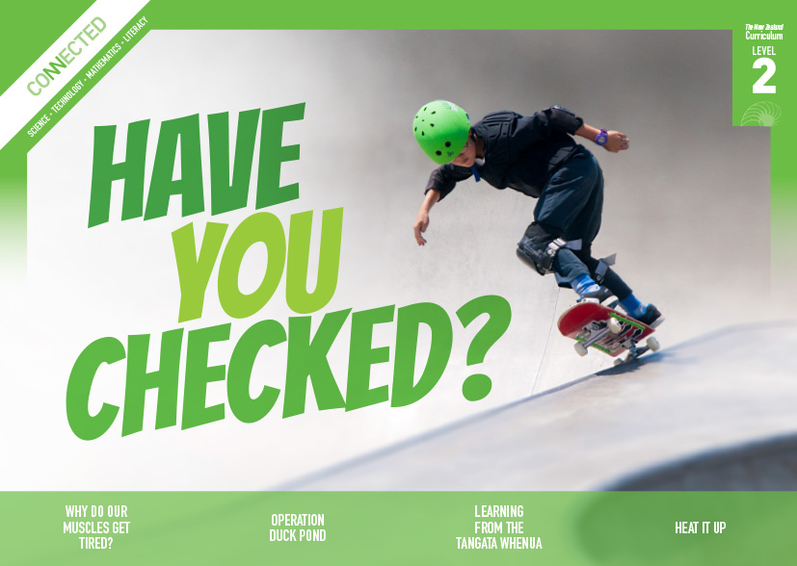  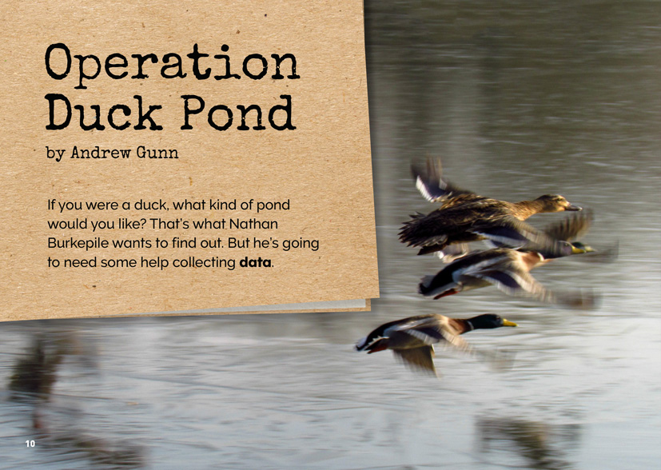
Science capability: Critique evidence |  | Text characteristics

Science knowledge is based on data derived from direct or indirect observations of the natural physical world. An inference is a conclusion drawn from those observations; it is the meaning you make from the observations. Understanding the difference between an observation and an inference is an important step towards being scientifically literate.  Being ready, willing, and able to critique evidence is also an important step towards being scientifically literate. Students must be able to assess the quality and reliability of both the observations (data) and the inferences made from those observations. In order to know what sorts of questions to ask to evaluate the trustworthiness of data, students need both methodological knowledge (how data is generated and collected) and statistical knowledge (how data is collated and analysed).  For more information about the “Critique evidence” science capability, go to http://scienceonline.tki.org.nz/Introducing-five-science-capabilities/Critique-evidence |  | - Clearly structured text with headings that signal the information in each section and help the reader to navigate the text.  - Many subject-specific words with their meanings explained in the running text and in the glossary.  - Breakout text to provide supplementary information.  - Images and photographs with captions that clarify the text and require some interpretation.

Curriculum context

SCIENCE
NATURE OF SCIENCE: Understanding about science  Achievement objective  L2: Students will appreciate that scientists ask questions about our world that lead to investigations and that open-mindedness is important because there may be more than one explanation. |  | LIVING WORLD: Ecology  Achievement objective  L2: Students will recognise that living things are suited to their particular habitat.  LIVING WORLD: Evolution  Achievement objective  L2: Students will recognise that there are lots of different living things in the world and that they can be grouped in different ways. |  | Key Nature of Science ideas  Scientists:  - evaluate the trustworthiness of data by asking questions about investigations carried out by others  - undertake more than one trial to provide sufficient evidence to support a theory  - replicate investigations to critique the evidence or data provided by other scientists  - check that there are enough samples to reliably establish a conclusion or theory  - look carefully at the way data has been collected when they consider investigations done by others.  Key science ideas  - Living things are suited to their particular habitat.  - Animals can be grouped together according to their shared features.

ENGLISH

READING  Ideas  Students will show some understanding of ideas within, across, and beyond texts. |  | INDICATORS  - Uses their personal experience and world and literacy knowledge to make meaning from texts.  - Makes meaning of increasingly complex texts by identifying main ideas.  - Makes and supports inferences from texts with some independence. |  | THE LITERACY LEARNING PROGRESSIONS  The literacy knowledge and skills that students need to draw on by the end of year 4 are described in The Literacy Learning Progressions.

Critiquing evidence

The science capability “Critique evidence” is about students evaluating the quality of the data supporting a scientific claim or idea (http://scienceonline.tki.org.nz/Introducing-five-science-capabilities/Critique-evidence).
Scientists use empirical evidence to develop theories about how the world works.
- Empirical evidence is data gathered from observations, experiments, and investigations.
- Scientific claims are only as dependable as the evidence on which they are based.
- Scientists design their investigations carefully to ensure that the data they gather is both reliable and valid. Valid data is data that measures what it is supposed to measure – it answers the research question. Reliable data is dependable and consistent. Replicating the experiment and getting the same results makes us more confident the data is reliable.
- To gather high-quality evidence that is reliable and valid, scientists measure accurately, keep conditions the same or control variables that might influence measurements or observations, repeat tests or investigations many times, investigate multiple examples, and/or use statistical sampling techniques to make their observations or data as representative and accurate as they can.
Students should be critiquing and evaluating the quality of data gathered from their own investigations by:
- engaging in a range of investigation types, exploring, comparing, classifying, identifying, seeking patterns, using models, making things to test ideas, and investigating systems so that they learn different ways to gather different types of data
- identifying ways to make the data they collect in their own investigations as accurate and reliable as possible
- suggesting and developing ways to control conditions or variables or keep things fair, repeating observations or measurements or tests, and developing appropriate sampling methods
- applying their developing understanding of statistics and probability when making decisions about sample size and repetitions, and when working with their data.
Students should also be encouraged to look for, consider, and critique methods and data underpinning scientific claims made by others. This includes critically examining the appropriateness of methods and the quality of evidence used to develop scientific claims in the media and other sources.
Teachers can:
- help students to be more critical consumers of science information by being explicitly critical themselves
- support students to identify correlations as evidence of a potential relationship, but not necessarily cause and effect
- ask questions around the reasons for having strict data collection protocols in citizen science projects and the significance of the size of data sets
- support students to evaluate how data is presented; for example, if data is presented graphically, is this done appropriately or is it misleading? (This draws on another science capability, Interpret representations.)
- support students to apply their understanding of statistics and probability when considering claims, evidence, and data.
- establish a science classroom culture by:
  - modelling and encouraging a critical stance
  - encouraging students to consider the quality and interpretation of data underpinning scientific claims
  - using media headlines to introduce learning conversations and demonstrate the relevance of critiquing evidence to everyday life.
A range of questions and activities designed to get students to critique evidence is available on the Science Online website: http://scienceonline.tki.org.nz/Introducing-five-science-capabilities/Critique-evidence

Meeting the literacy challenges

This text uses a combination of photos and written information to communicate ideas and information to the reader. The literacy demand lies in the interpretation of the data-gathering process. Subject-specific and science academic language may be challenging for some students.
The following strategies will support students to understand, respond to, and think critically about the information and ideas in the text. You may wish to use shared or guided reading, or a mixture of both approaches, depending on the reading expertise of your students or on the background knowledge they bring to the text.
After reading the text, support students to explore the activities outlined in the following pages.

TEACHER resources

Want to know more about instructional strategies? Go to:
- http://literacyonline.tki.org.nz/Literacy-Online/Teacher-needs/Reviewed-resources/Reading/Comprehension/ELP-Years-1-4
- “Engaging Learners with Texts” (Chapter 5) from Effective Literacy Practice in Years 1 to 4 (Ministry of Education, 2003).
Want to know more about what literacy skills and knowledge your students need? Go to:
- http://literacyonline.tki.org.nz/Literacy-Online/Student-needs/National-Standards-Reading-and-Writing
- http://www.literacyprogressions.tki.org.nz/
“Working with Comprehension Strategies” (Chapter 5) from Teaching Reading Comprehension (Davis, 2007) gives comprehensive guidance for explicit strategy instruction in years 4–8.
Teaching Reading Comprehension Strategies: A Practical Classroom Guide (Cameron, 2009) provides information, resources, and tools for comprehension strategy instruction.

INSTRUCTIONAL STRATEGIES

FINDING THE MAIN IDEAS
DISCUSS the title and the text on page 10. Provide a brief overview of the text. Tell the students that the headings provide a clue about the content on each page and that the information is written like a report. Draw their attention to the visual features such as the photos, maps, and captions and the information box on page 15.
Ask questions to help the students make connections to their prior knowledge and to build understanding of the text content before they read.
- What do the words “Operation Duck Pond” make you think about?
- What is the effect of the first sentence? How does the author want you to respond?
- What does the word “data” mean?
- What sort of data do you think Nathan might need in order to find out about the sort of pond a duck would like?
You may need to clarify that the purpose of Operation Duck Pond is not to create designer ponds for ducks but to help landowners manage their ponds so that they provide safe places for waterbirds to breed (see www.fishandgame.org.nz/operation-duck-watch-nationwide-‘citizen-science’-project-0).
ASK the students:
- Why is it important to provide the citizen scientists with clear instructions for collecting data?
- How did Nathan improve the instructions he was giving the citizen scientists? What impact did this have on the data?
Have the students reflect on the information and use what they know to critique Nathan's investigation.
- Is Nathan collecting the right sort of data to answer his question?
- How has Nathan tried to make sure his data is trustworthy?
- Do you agree that a website might make it easier for the observers to record their data and for Nathan to analyse it? Why, or why not?
- Can you think of other things Nathan might do to improve the validity and reliability of his data?

USING PHOTOGRAPHS AND IMAGES TO CLARIFY THE TEXT
Have the students look closely at the map on page 11. ASK QUESTIONS to help the students make connections between the information in the map and their own context.
- Where do we live? Are there any observed ponds near us?
- Do you know of any ponds that are not shown on the map and that get a lot of ducks?
ASK the students to look closely at one of the photographs of the people, to read its caption, and then to complete the following chart, writing a sentence for each item.
This photo is on page __
Who is in the photo? | What they are doing?
Why are they are doing it? | Why is this photograph in the article?
DISCUSS how the photographs, images, and captions help to explain the text.
- How well do you think you would have understood the text if it did not have these visual features?
- Is there information in the photographs and map that you did not also get in the text?
- How did the captions help you to understand what you were looking at in the photographs? How important were they?

DEALING WITH UNFAMILIAR VOCABULARY
EXPLAIN to the students that many of the words in the text may be unfamiliar to them. Ask them to think, pair, and share the variety of ways the words are explained:
- in the glossary
- in the text
- in the captions
- visually, in the photographs
- in the break-out text
- through repetition so that the reader becomes familiar with the word and builds up a deeper understanding of what it means.
Encourage the students to keep a RECORD of all new terms in their science notebooks or on a class word wall.
Students could record their predictions of unfamiliar words in a simple chart. For example:
Word or phrase | What I think it means | What it does mean
Prior to reading the text on page 11, ASK the students to make predictions about what the term “citizen scientist” could mean.
- What does the word "citizen" mean? What is a "scientist"? So what is a "citizen scientist"?
RECORD the students’ predictions and then REVIEW them with the students after reading page 11. Following the reading, you could use the Science Learning Hub link on citizen scientists (http://sciencelearn.org.nz/Science-Stories/Butterflies/Citizen-scientists) to explore this concept and to find out about citizen science in action.
When the students first meet the word “reliable” on page 12, ASK them to think, pair, and share possible definitions. Use their responses to construct a shared definition and then compare their definition to the definition in a dictionary. They should record the definition they think is best. Make sure that the students understand that "reliability" refers to whether the data represents reality – whether it can be trusted. As they read, have them create a LIST of what Nathan has done to ensure the validity of his data.
Before the students read the breakout text headed “Outliers” on page 15, present them with the scenario where “nine observers report twenty to thirty ducks on their ponds, but one observer reports three hundred”. DISCUSS the possible reasons for such a surprising difference and then have them read the text to check whether they have considered all the likely possibilities.

Key science ideas
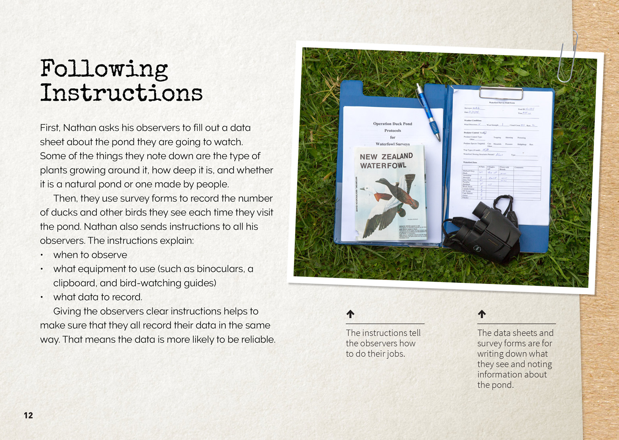 | Citizen scientists gather data from observations.  Citizen scientists make multiple observations to collect data.  Collecting data in the same way makes us more confident the data is reliable.
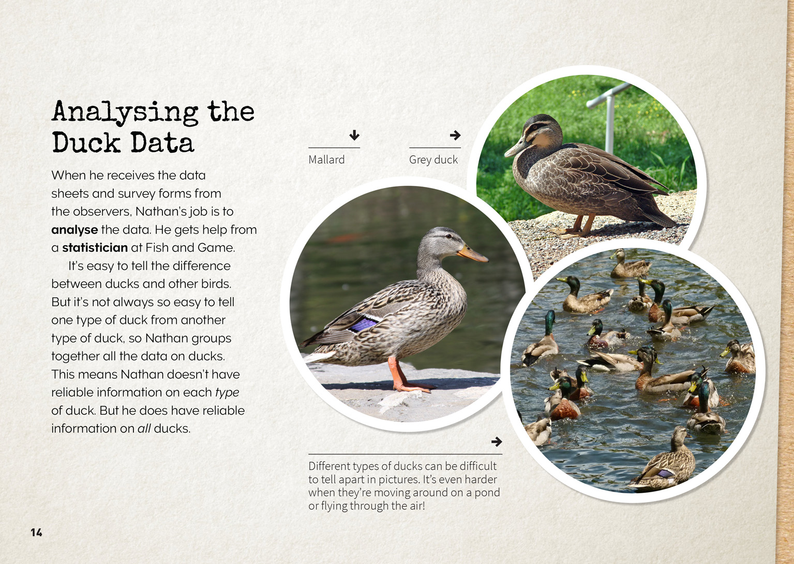 | Ducks can be grouped in different ways.  Scientists design their investigations to ensure the data they gather is reliable.  Scientists evaluate the reliability of the data collected.

Learning activities
The following activities and suggestions are designed as a guide for supporting students to explore and develop understandings about the science capability “Critique evidence”. Some activities focus directly on the science capability. Other activities extend student content knowledge across the learning areas. You are encouraged to adapt these activities to support your students’ learning needs.

exploring the science

Activity 1: Exploring our environment
This extended activity is intended to deepen students’ understandings about how to conduct observations that generate reliable data. As it proceeds, prompt them to critique their data and the inferences they draw. Be deliberate about your use of such scientific terminology as “reliability”, “data”, “inference”, “analyse”, and “outlier”.
Making links to new contexts
Build on the knowledge the students gained from reading “Operation Duck Pond” by reading “The Takeaway Table” from Connected 2, 2013. This article describes how Room 3 conducted an observation and the strategies they put in place to ensure that their results were reliable. It shows how these students rethought their recommendations for the construction of a bird table in the light of new information. Prompt your students to critique Room 3's data.
What are the reasons for the observation rules? Can you see any possible problems with this method?
Compare the observation form on page 23 with the purpose for the investigation on page 21. Do you think the observation form provides all the data that Room 3 needs? What do you notice about the way it is laid out? How will that help ensure that the class gets reliable data?
Read the log on page 24. What is the purpose of the log? How might it have helped Room 3 when it came time to analyse their data?
Look at the graph on page 25. What is the purpose of the graph? What are some inferences you could draw from reading the results of this graph? Can you see any outliers in the data? What might account for those outliers?
What do you think was surprising in the email from the Korimako Bird Watchers' Club? Have the students compare this to the information on page 23 from the Field Guide to the Birds of New Zealand about what silvereye/tauhoe like to eat.
What conclusions can you draw about the reliability of Room 3's data?
Designing an investigation
Conduct a think, pair, and share about the types of data that the students could gather from the school or wider community, seeking similar data to that generated by the class in “The Takeaway Table”. Share the students’ ideas to create a class mind map that clusters linked ideas. The main idea is “Investigating a part of our environment”.
If the students have difficulty generating ideas, you could get them started with the following suggestions:
Monarch butterflies: How many monarch caterpillars are there on each swan plant in the school garden? What might account for the differences? How might we use this information to increase the number of monarch butterflies we are able to hatch?
Recycling: How much paper and how much plastic is recycled in each classroom, each day? What might account for the differences? How might we use this information to suggest improvements to the way rubbish is recycled at our school?
Insects: What are the dominant insects in different parts of our school? What do we expect to find? (And later, what did we find?) Which are beneficial to our school gardens, and which would we call pests? What attracts them? How might we use this information to increase the productivity of our gardens?
Birds: What species of birds visit our school playground? Do different birds visit at different times of the day? How do our results compare to those for Room 3? How might you explain those differences? How could we use this information?
Investigating a part of our environment
For example, recycling
The students select one of the ideas in the class mind map as the basis for designing their own investigation. Working first in groups and then as a class, have them use the observation rules and survey forms used by Room 3 as models for creating their own. Each group can then present their designs and the class can critique the designs to decide which will give them the most trustworthy data.
Conducting an investigation
Have the students conduct the selected investigation over a set period of time. Before they begin, have them make predictions about what they will find and record their predictions in their science notebooks. During the investigation, they could share their observations and thoughts in class discussions and a class blog. Prompt them to ask questions and share interesting discoveries, for example:
Does it make a difference if you spend a long time or a short time doing the observation?
Who might have more information about this?
After the students have finished collecting their data, encourage them to draw upon their mathematical knowledge and skills to decide the best way to graph it. Then support them to draw inferences from their results, reminding them of the sorts of questions Nathan asks about his data. Questions could include:
What can we infer from our data? How can we justify our inferences?
Are the results what we predicted?
Are there are any outliers? If so, how can we explain them?
What are some statements we could make to explain what we found?
Taking action
After they conducted their observations, Room 3 constructed a bird table and contributed an article to an online community newspaper. Ask your students whether there are actions they would like to take on the basis of their investigation. This discussion could lead to the decision to embark on a technology project and/or a decision to explore an appropriate way of communicating what they have learned.
What are some of the implications of our findings? How could we use them to make a positive difference to our environment?
Who might be interested in what we found? Why? What would be a good way of sharing this information with our audience?
Extension
An option is that the students might decide that they need more data to improve the reliability of their findings or that they would like to get additional data that they can compare with their own. To do this, they might choose to make a connection with another class or school and invite them to repeat the investigation. If so, they will need to give careful instructions to ensure that the other group’s investigation is reliable. Your students will need to review their instructions and forms and provide any necessary explanatory information. Remind them of how useful they found the photographs in the Connected articles and suggest they could support the explanations with their own captioned photographs. They could share this material using an online facility such as Google Docs or Dropbox.

Activity 2: Why become a citizen scientist?
The notion of a “citizen scientist” has links to the broader concepts about citizenship in the New Zealand Curriculum. Citizenship is about individual growth and the contributions we can all make to the multiple communities to which we belong, at home, in the school, in the community, in the nation, and as citizens of an increasingly globalised world. The social science texts “Belonging and Participating in Society” and “Being Part of Global Communities” offer ways to explore these concepts.
Citizen scientists contribute to the growth of scientific knowledge. The resource links include the Connected 2, 2013 articles “The Takeaway Table” and “Look out for Monarchs” and several items on the Science Learning Hub that will help the students construct an understanding of this term. As the students consider the concept of citizen science, collect their thinking in a table like the following, which is intended to show the benefits of active participation in science.
Benefits of becoming a citizen scientist …
… to the individual | … to the community | … to the environment | …to science
The students could interview a citizen scientist to find out what they are doing and why they are motivated to do it. They could interview the citizen scientist in person or via Polycom or Skype. They will need to write questions and record the answers.
Have the students use what they learned from the interview to add to or refine their table and to prompt a call to action.
What is a contribution we could make to our community as citizen scientists?
The teacher support materials for “Look out for Monarchs” (Connected 2, 2013) and “Counting Kākahi” (Connected 3, 2014) suggest practical ways in which students could take action as citizen scientists. The resources listed below provide other options:
Nature Watch New Zealand is a site that New Zealand citizen scientists can use to pool their observations of the natural world. They can participate in established projects or create their own. Two of those projects have been created by Te Papa.
King Tides Auckland is a community initiative that gives citizen scientists in Auckland the opportunity to contribute to knowledge about the impact of sea level rise.
The Lost Ladybug Project is a project based in North Carolina, but might be adapted to New Zealand, perhaps as a Nature Watch project. It is a response to concerns about changes in the ladybug population.

Activity 3: More about ducks
Have the students use the resources Building Science Concepts book 3 – Birds: Structure, Function, and Adaptation, the Fish and Game site, Department of Conservation site, and “Ducks Unlimited”, as well as others they find using their own inquiry skills to:
find out what different species of ducks eat
find out about the features of ducks that make them suited to life on ponds (webbed feet, bills, waterproof feathers)
learn more about duck breeding and how ducks care for their young
find out how ducks are classified into different species
learn about the role of territory in different duck populations (some are territorial, others are not, and some become territorial under certain conditions).
The students could work in groups to gather information about one question each and to plan how they will organise it in a way that makes it easily accessible to the whole class.
Move the discussion to focus on the work Nathan is doing. Page 11 of the article explains that Nathan works for Fish and Game New Zealand and that Fish and Game “aims to protect fish and birds so there will always be enough of them for people to hunt and fish”. This is an interesting statement that students may like to debate.
“Why does an organisation that supports hunting work to protect animals?”
Explore the information on Fish and Game's website and view the video “The Flight of the Mallard” to help the students better understand the purpose of Nathan's research: to find out how ponds can help the conservation of waterfowl in the face of the loss of naturally occurring wetlands.
Use Building Science Concepts book 3 – Birds: Structure, Function, and Adaptation to help the students understand the importance of habitat and the fact that many of New Zealand's native species are highly specialised – they have unique adaptations that restrict them to particular habitats. Use this and the other suggested resources to find out:
Why are some ducks rare in New Zealand (for example, the brown teal/pāteke and the blue duck/whio)?
What is being done to protect them? Why is their conservation important?
Visit a local pond and carry out the same kind of observations as detailed in the story. The students could take photographs or draw sketches to help them classify the different ducks they see. If the pond is one of those included in Operation Duck Pond, this could be an opportunity for the students to interview an observer and find out why they are taking part, what the experience has been like, and what they have seen.
Extension
Find out about the habitat of another kind of species. The students could visit a zoo or wildlife centre to find out about how the people at these places construct enriched enclosures that are suited to their animals’ needs.

RESOURCE LINKS

Building Conceptual Understandings in the Social Studies
Ministry of Education (2008). Belonging and Participating in Society from the Building Conceptual Understandings in the Social Sciences series. Wellington: Learning Media. See http://ssol.tki.org.nz/Social-studies-Years-1-10/Teaching-and-learning/effective_teaching_in_social_studies/building_conceptual_understandings/belonging_and_participating_in_society
Ministry of Education (2009). Being Part of Global Communities from the Building Conceptual Understandings in the Social Sciences series. Wellington: Learning Media. See http://ssol.tki.org.nz/Social-studies-Years-1-10/Teaching-and-learning/effective_teaching_in_social_studies/building_conceptual_understandings/being_part_of_global_communities

Connected
“Counting Kākahi”. Connected 3, 2014, pp. 8–13.
“Look out for Monarchs”. Connected 2, 2013, pp. 28–32.
“The Takeaway Table”. Connected 2, 2013, pp. 20–27.

Fish & Game New Zealand
“Mallard Duck Research” www.fishandgame.org.nz/mallard-duck-research
“The Flight of the Mallard – a documentary about the Fish & Game research program” www.vimeo.com/80518678
“Operation Duck Pond – A Nationwide Citizen Science Project” www.fishandgame.org.nz/operation-duck-watch-nationwide-‘citizen-science’-project-0 and www.facebook.com/pages/Operation-Duck-Pond/677991852233814

Nature Watch NZ
Nature Watch NZ homepage http://naturewatch.org.nz – New Zealand citizen scientists can use this site to pool their observations of the natural world. They can participate in established projects or create their own.
“Ferns with Te Papa” http://naturewatch.org.nz/projects/ferns-with-te-papa
“Spiders with Te Papa” http://naturewatch.org.nz/projects/spiders-with-te-papa

Te Papa Tongarewa
“DeCLASSIFIED! Nature's Secrets Exposed” www.tepapa.govt.nz/WhatsOn/exhibitions/Pages/DeCLASSIFIEDNaturesSecretsExposed.aspx – A page about recent discoveries made by Te Papa scientists, and how citizen scientists can help.

Science Learning Hub
“Citizen scientists” http://sciencelearn.org.nz/Science-Stories/Butterflies/Citizen-scientists
“Student Activity – Ethics in bird conservation” http://sciencelearn.org.nz/Science-Stories/Conserving-Native-Birds/Ethics-in-bird-conservation
“Student Activity – Tagging monarch butterflies for science” http://sciencelearn.org.nz/Science-Stories/Butterflies/Tagging-monarch-butterflies-for-science

Other resources
Building Science Concepts book 3 – Birds: Structure, Function, and Adaptation
“Citizen Scientists” from Education Aotearoa. www.educationaotearoa.org.nz/all-stories/2013/5/6/citizen-scientists.html
“Determining the extent of Grey Duck x Mallard hybridisation in New Zealand” from the Department of Conservation. www.doc.govt.nz/documents/science-and-technical/SP32.pdf
”Ducks Unlimited New Zealand” www.ducks.org.nz/duck.htm
“Garden Bird Survey” from Landcare Research, Manaaki Whenua. http://www.landcareresearch.co.nz/science/plants-animals-fungi/animals/birds/garden-bird-surveys
“King Tides Auckland” http://auckland.kingtides.org.nz; Facebook.com/kingtidesakl; Instagram.com/kingtidesakl
“Marine Metre Squared” www.mm2.net.nz/
“The Lost Ladybug Project” www.lostladybug.org
“Wetland and river birds” from the Department of Conservation. http://www.doc.govt.nz/nature/native-animals/birds/wetland-and-river-birds/
”What is Citizen Science?” from SciStarter. http://scistarter.com/page/Citizen%20Science.html

Google Slides version of “Operation Duck Pond” www.connected.tki.org.nz

